**Modeling Toolbox Readme Part 1. Generating Models**

**Generate Fake Fascicle model**

1. open Simple_Fascicle_Maker.m in ‘Nerve Tracing’
2. hit “run”. This creates a fake fascicle and labels where to export locations. It also creates an sm2 file, ‘simplesm2.sm2’, which can be opened with Maxwell. Then follow from step 3 below.

**Or convert Image to Fascicle model**

1. If you have an image, run Matt’s NerveTracer.m . This is in the ‘Modified Tracing’ folder. Open the file you want to use. Adjust the BW slider to only hit the fascicles you want or manually trace fascicles. Don’t be too diligent - whatever you trace gets resampled to only 20 points anyway. Select ‘name each fascicle’. Name each one ‘Peri[k]’ where [k] is the fascicle number. Click ‘trace scale bar’ and follow instructions. Click ‘run reshaper’ – this prompts you to trace the epineurium. Do so. When you’re done, an error pops up in Matlab. Ignore it and keep going.
2. You should now be in the Nerve Reshaper gui. Click ‘Objects contain appropriate strings ‘Epi’ and ‘Peri’. ’. Enter nerve cuff dimensions (inner). If you add encapsulation, that is 0.25mm around the edge. The script will bug out or stop sooner or later – this means it’s done. Hit “export sm2” to generate a file used by Maxwell (WriteSM2).
3. Move the .sm2 back into the parent toolbox directory “…\Modeling Toolbox 2019\”

**Example**

Run NerveTracer.m, which is inside ‘Nerve Tracing’

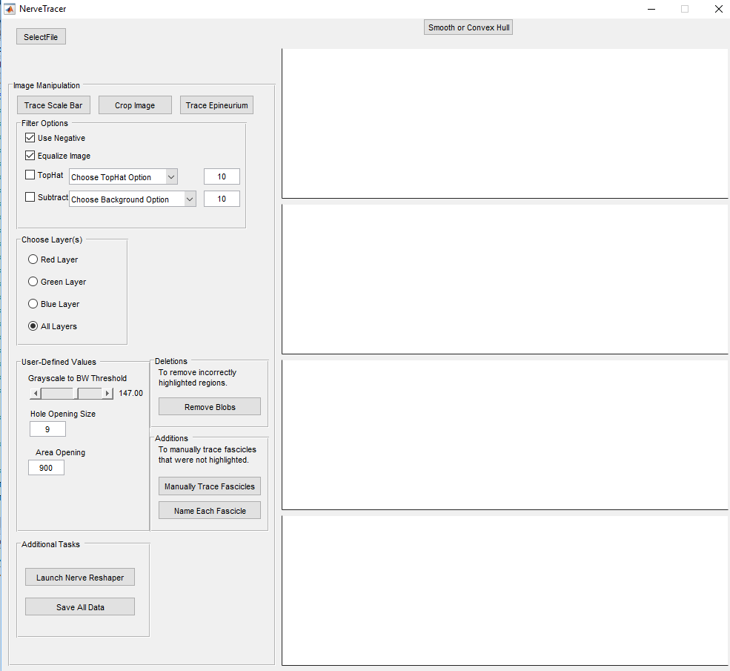

Select file.

The ‘test’ subfolder has an image, M1.bmp.

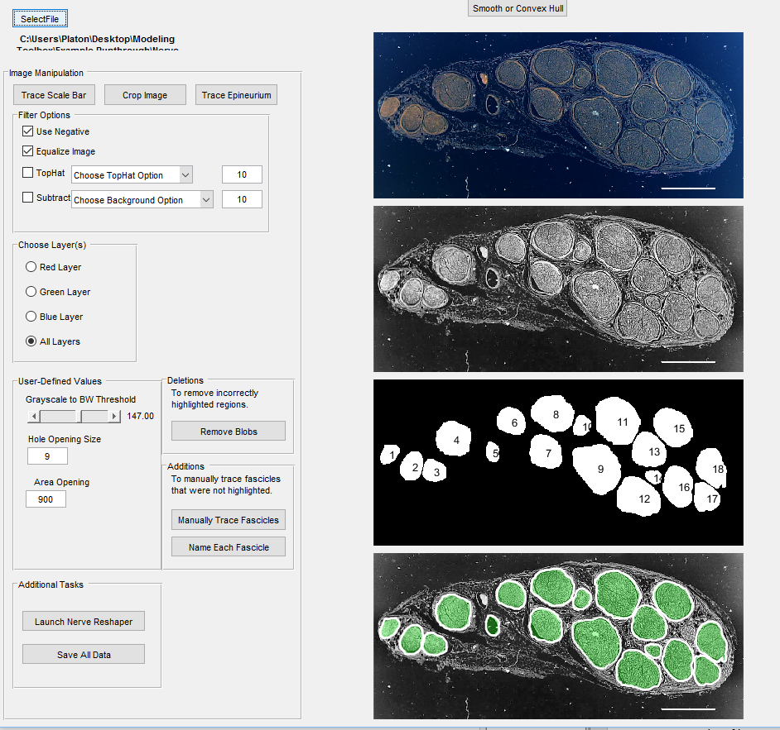

For now we’ll go with a simple version, and only select a few fascicles.

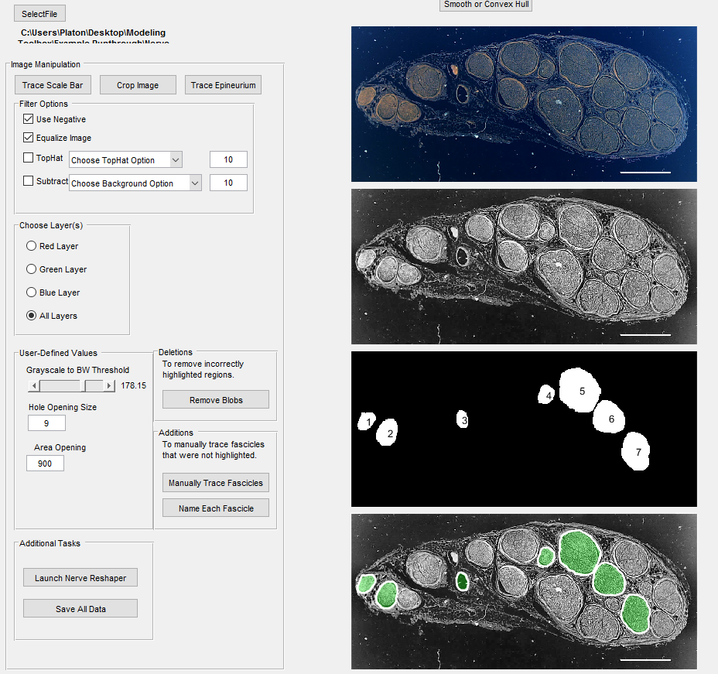

“Name Each Fascicle”, then name them Peri1…Peri[k]



“Trace Scale Bar” and follow instructions

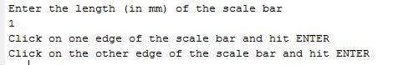

“Run Reshaper”

This will trigger “Trace Epineurium”. Follow the instructions

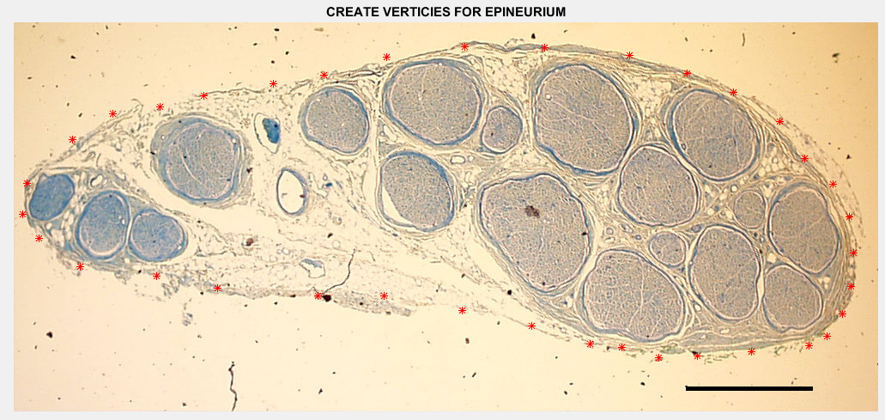

After you type ‘Done’, you will get this error:

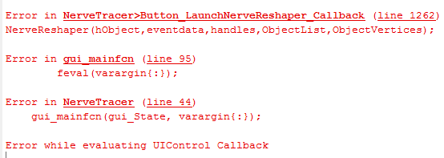

Ignore it. A new GUI should have popped up

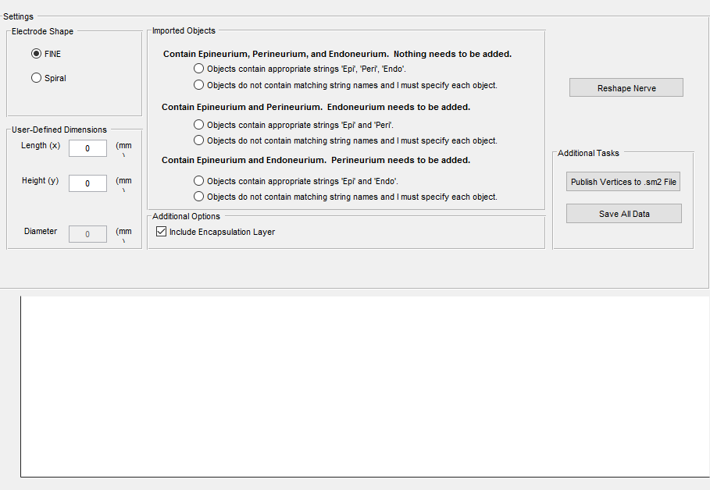

Choose the 3rd option down: “Objects contain appropriate strings ‘Epi’ and ‘Peri’”.

Also add the cuff dimensions: In this case, height 3, length 10. Check-mark the encapsulation layer (0.25mm around edge)

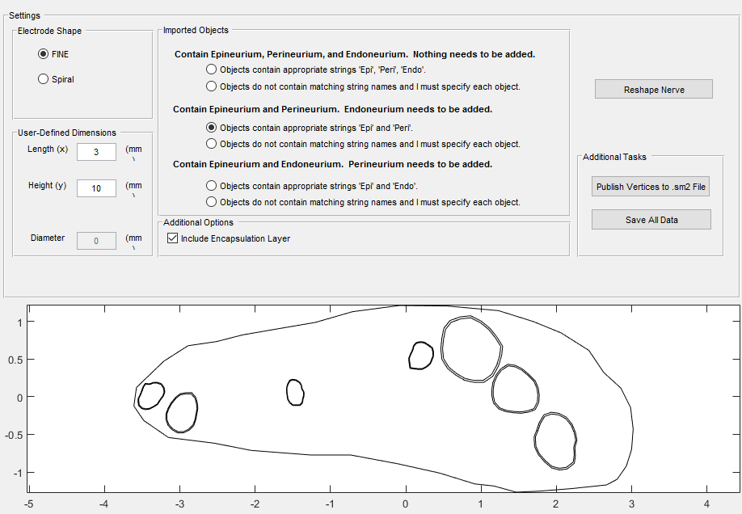

Then click ‘reshape nerve’. You’ll see some fascicles moving, before everything stops. This tends to run in batches – don’t bother changing anything until you receive an “elapsed time” message

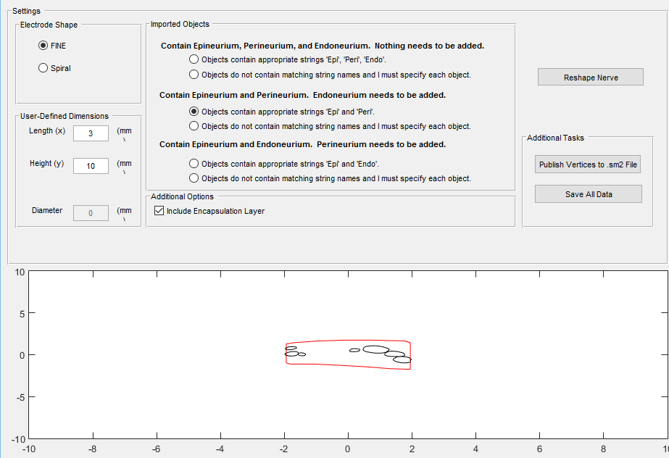

At this point, “publish vertices to sm2” and name the file in Matlab.

Something like this will appear in the Nerve Tracing folder:



Take that file, and copy it out of the Nerve tracing folder to “…\Modeling Toolbox 2019\”

**Example continued in readme part 2. Going from Models to Voltages**